Common Errors encountered in Learning Python

Common Errors faced while taking Baby Steps in the learning path of Python

As we take baby steps in the path of learning Python, we encounter silly mistakes as similar to baby. Ours is a bit more as we try to learn on top of your other language exposure, but practicing what you learn will help you to master the language. Prepare yourself for Unlearning, when you need to. Assure you, leveraging on your earlier experience will help to leap forward in this journey. Continuous Learning also becomes a new Normal. Let us enjoy this journey!!!

Here, during the journey, trying to record all the syntax errors faced during the baby steps in learning Python and how the same can be identified (or how I have identified the mistake). Your inputs also will help as learning is more effective with the collective knowledge

NameError

When you start doing programming after a long break or while coding large programs, you tend to make mistakes in recollecting the names of variables you defined or used earlier, which you need to refer in other places. The error encountered during such scenarios will be as follows, remember **‘NameError’** refers to the variable naming (Will update if there is more!!!)

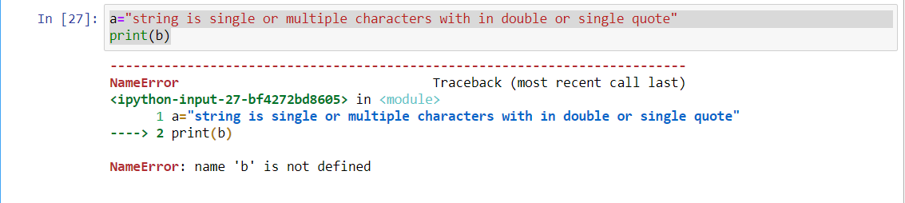

Look at the green highlighted text, ‘--🡪’, error pointer in Jupyter, where this error is being encountered

Description of the error is displayed beside the ‘NameError’ tag, as “name ‘b’ is not defined”

The intention is to display the content of the variable ‘a’ in the 2nd statement. Instead of referring to variable ‘a’, ‘b’ is used in the print() statement. Changing the variable name ‘b’ to ‘a’ in the 2nd statement will solve the error encountered

InvalidSyntax

The InvalidSyntax is encountered, when you did not follow the rule of the game and Python is not able to understand what you are trying to say.

Here in the following example, the string needs to be defined within quotation (single or double) but, tried to store in ‘a’ without the quotes.

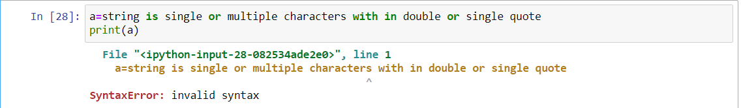

Here the error is indicated as it is occurring in ‘line 1’ and the assignment statement is highlighted.

By following the syntax rule, ie the string should be within quotes, we will be able to resolve the error.

Another example, when you miss the parenthesis in the print statement as given below

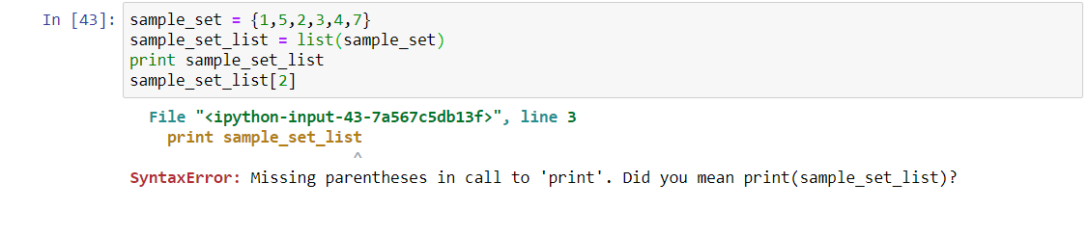

AttributeError

The AttributeError is encountered, when the object does not have the attribute which you are referring to.

In the following example, for the sample list we are able to sort, by calling the sort method within the list object, but when we try to do the same thing on a tuple object, we are not able to as this attribute is not applicable for tuple.

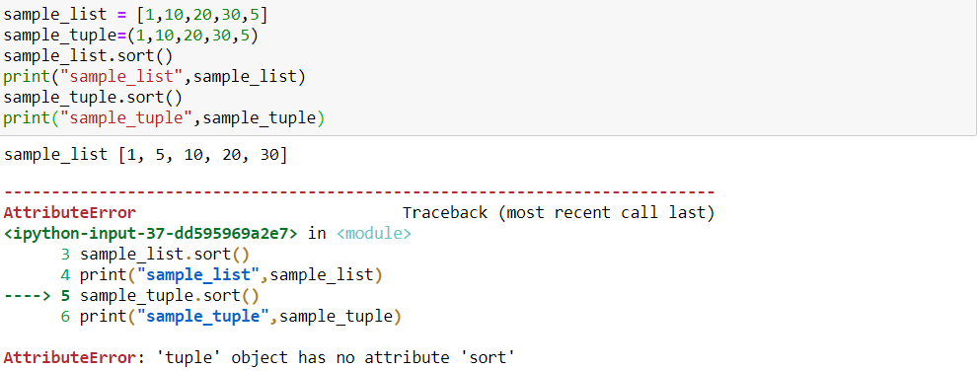

To get the sorted tuple, we need to used the sorted() function and then convert the result of sorted tuple returned as list to tuple

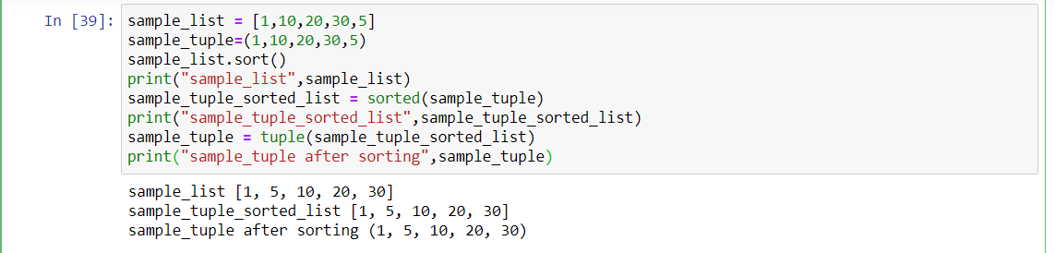

TypeError

The TypeError is encountered when try to refer elements within the set as in list. Since the set datatype, does not allow the reference by index, we get the error as TypeError

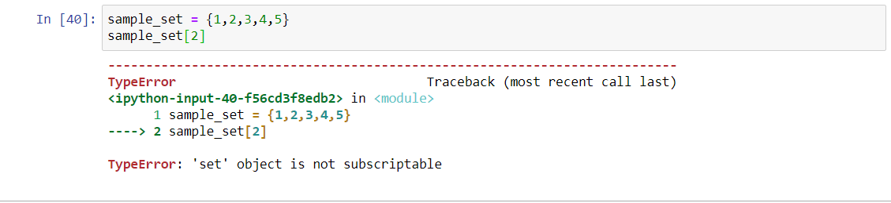

If you want to refer the elements, then you may convert the set to list and access the elements by index.

Note : Please note, the set is given in sorted order, so the index position of 2 of the list gives the same as in sample_set but look at the following, when the set is not in ordered order

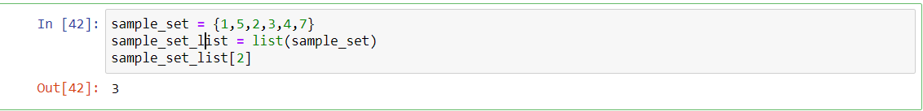

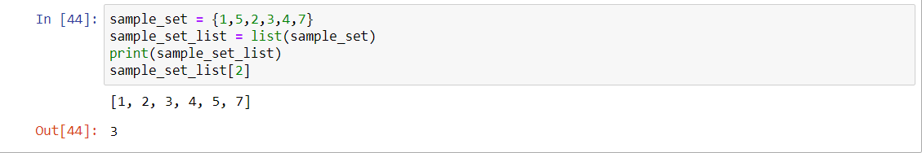

IndexError

If we refer the list elements by giving more than the length-1 or less than

-length(negative index), then we will get the index error.

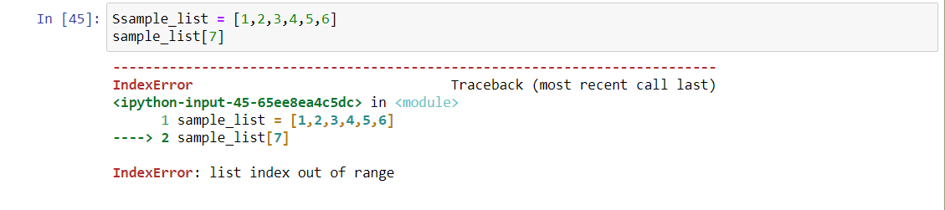

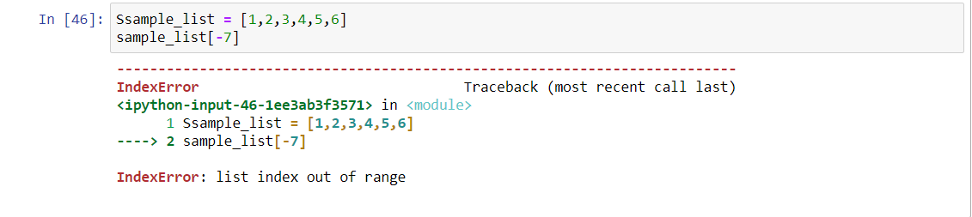

Normally, when we loop through the array, we are likely to make such errors.

To correct this, we need to ensure we are within the index range of the list or other iterables.

KeyError

If we refer the dictionary elements, with the invalid key, we get the KeyError.

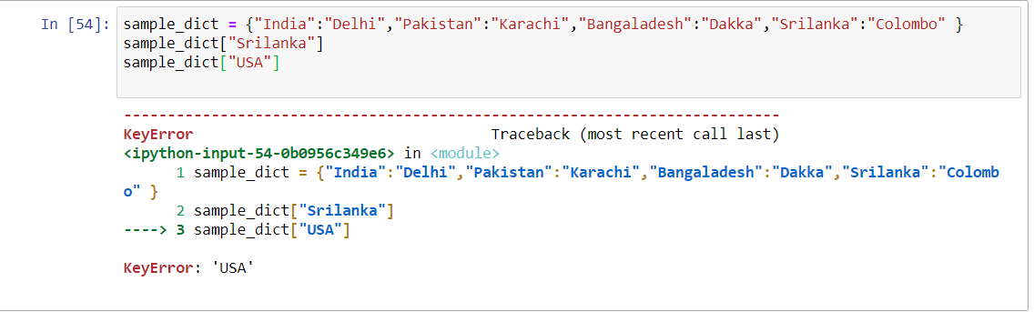

To avoid such error, we can use get method of the dictionary to find the key is there in the dictionary or not, before we refer the element with the same key.

To be continued ….. as part of the learning journey…. please refer the following link till then to know the list of errors <https://www.tutorialsteacher.com/python/error-types-in-python> or another if you prefer diagrammatic representation <https://pythonforbiologists.com/29-common-beginner-errors-on-one-page>